*Florida International University*

*School of Computing and Information Sciences*

Software Engineering Focus

Feature Document

User Story #119

Create Routes

**Name:** Nathally Perez and Mariana Sebastian

**Team Member(s):** Nathally Perez and Mariana Sebastian

**Project:** Driverless-Car-Website-1.0

**Product Owner(s)**: Kianoosh Gholami

**Mentor(s)**: Mohsen Taheri

**Instructor**: Masoud Sadjadi

**Create Routes:**

* As a developer, I want to create routes so that my application will respond to a client request to a particular endpoint.

Acceptance Criteria

* Web page should be properly rendered to the appropriate tabs

**Use Case**

* Name: create routes
* Actor: developer
* Preconditions:

1. Developer have access to the internet
2. Server is running on port 3000

* Description <Flow of events>:

1. Go to browser
2. Enter [http://localhost:3000](http://localhost:3000/)
3. Get request to server
4. Go to [http://localhost:3000](http://localhost:3000/)/contactus
5. Go to [http://localhost:3000](http://localhost:3000/)/about
6. Go to [http://localhost:3000](http://localhost:3000/)/mission
7. Go to [http://localhost:3000](http://localhost:3000/)/technology
8. Go to [http://localhost:3000](http://localhost:3000/)/team
9. Go to [http://localhost:3000](http://localhost:3000/)/product
10. Get view of each different routes

**Use Case Diagram**

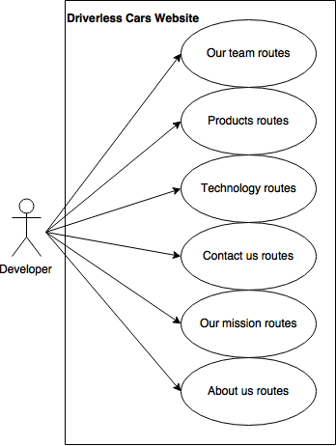

**Sequence Diagram**

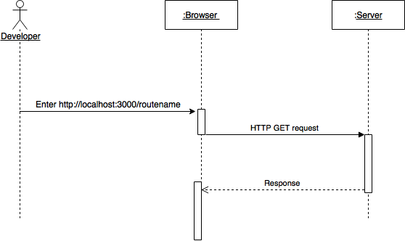

**Class Diagram**

N/A

**Unit Test:**

**Test case 1(Sunny Day)**

* Test case ID: DCW-119-01
* Description/Summary of Test: Ensure that each route is working properly.
* Pre-condition: The server is running on the localhost port 3000.
* Expected Results: Developer is able to access successfully:
* [http://localhost:3000](http://localhost:3000/)/contactus
* [http://localhost:3000](http://localhost:3000/)/aboutus
* [http://localhost:3000](http://localhost:3000/)/mission
* [http://localhost:3000](http://localhost:3000/)/technology
* [http://localhost:3000](http://localhost:3000/)/team
* [http://localhost:3000](http://localhost:3000/)/product
* Actual Result: Developer was able to access routes successfully.
* Status (Fail/Pass): PASSED

**Test case 2(Rainy Day)**

* Test case ID: DCW-119-02
* Description/Summary of Test: Ensure that the routes is working properly.
* Pre-condition: The server is running on the localhost port 3000, but developer input:
* [http://localhost:3000](http://localhost:3000/)/contact
* [http://localhost:3000](http://localhost:3000/)/about
* [http://localhost:3000](http://localhost:3000/)/missio
* [http://localhost:3000](http://localhost:3000/)/technolo
* [http://localhost:3000](http://localhost:3000/)/tea
* [http://localhost:3000](http://localhost:3000/)/products
* Expected Results: Developer is unable to access the routes successfully.
* Actual Result: Developer was not able to access the routes successfully due to incorrect link.
* Status (Fail/Pass): PASSED

**Integration Test**

The integration test was made using postman and I tested each of the routes and I did not have bugs and they were functioning correctly. The result were positive.

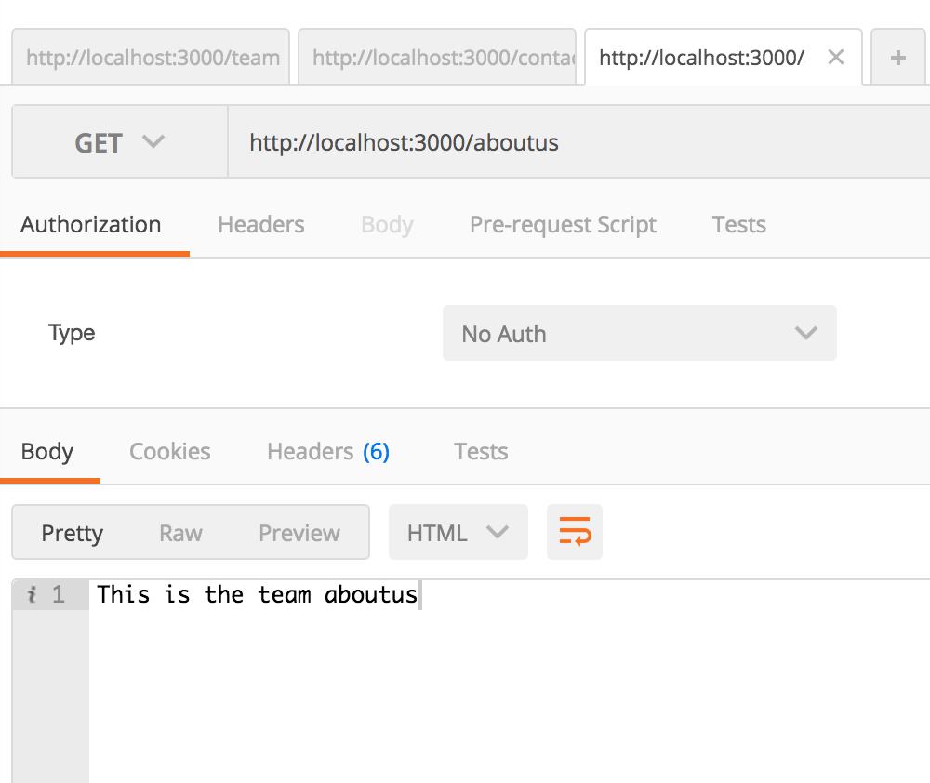

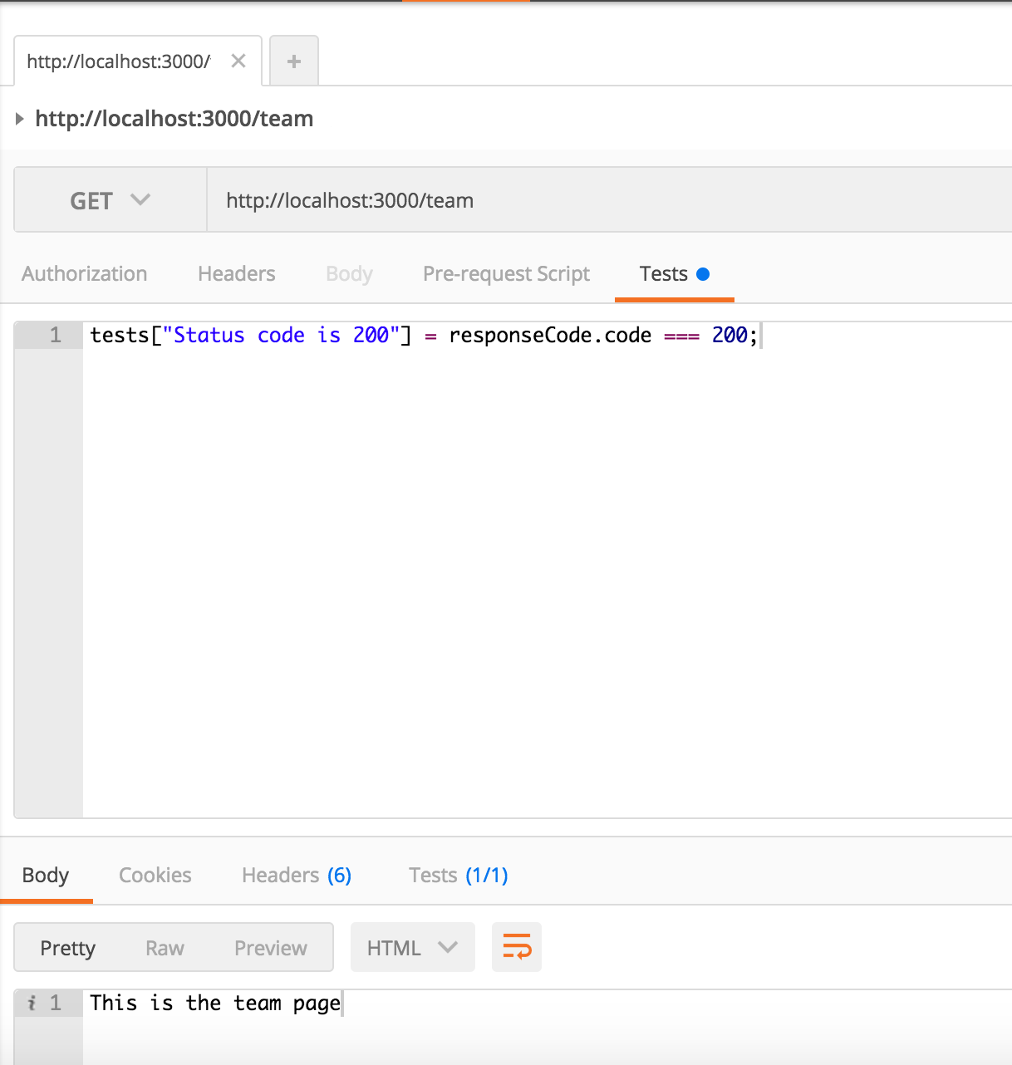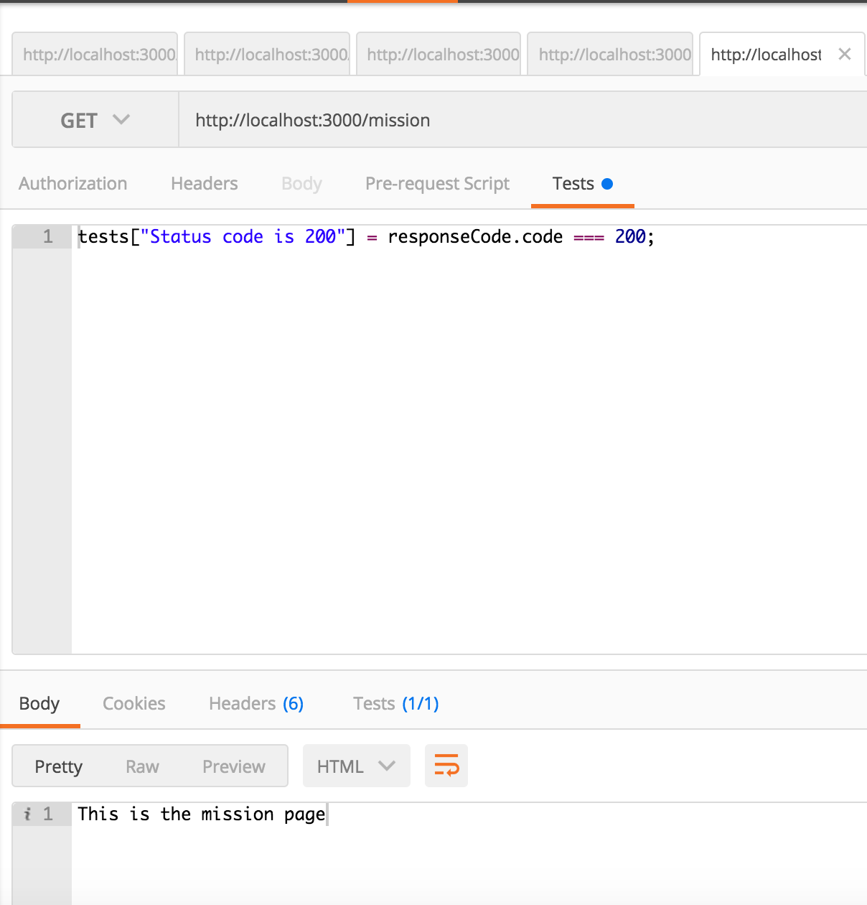

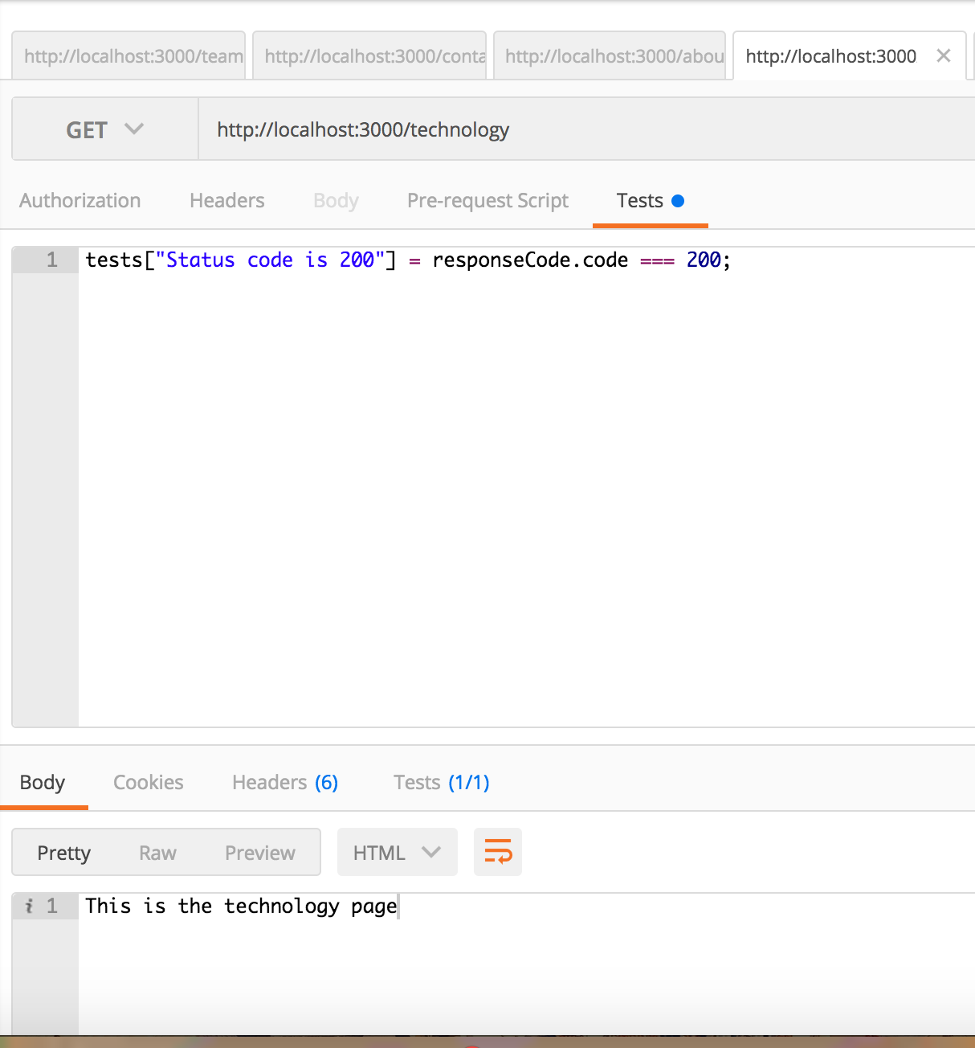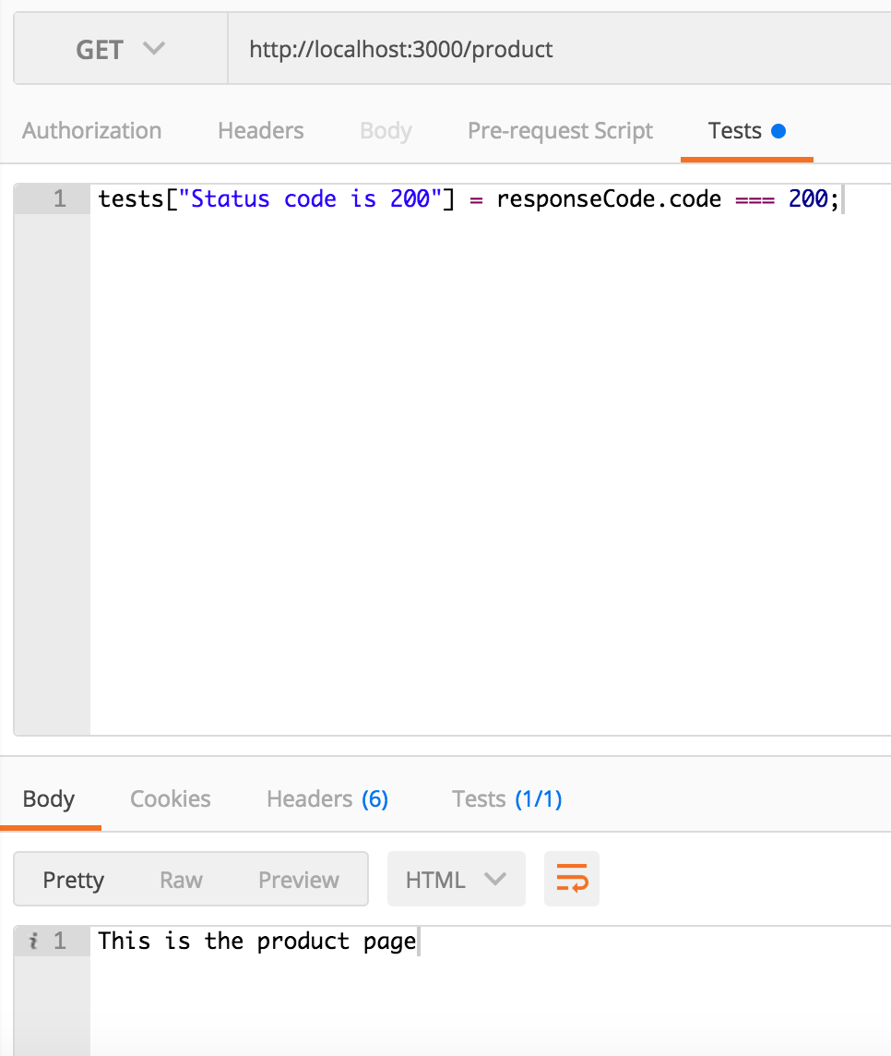

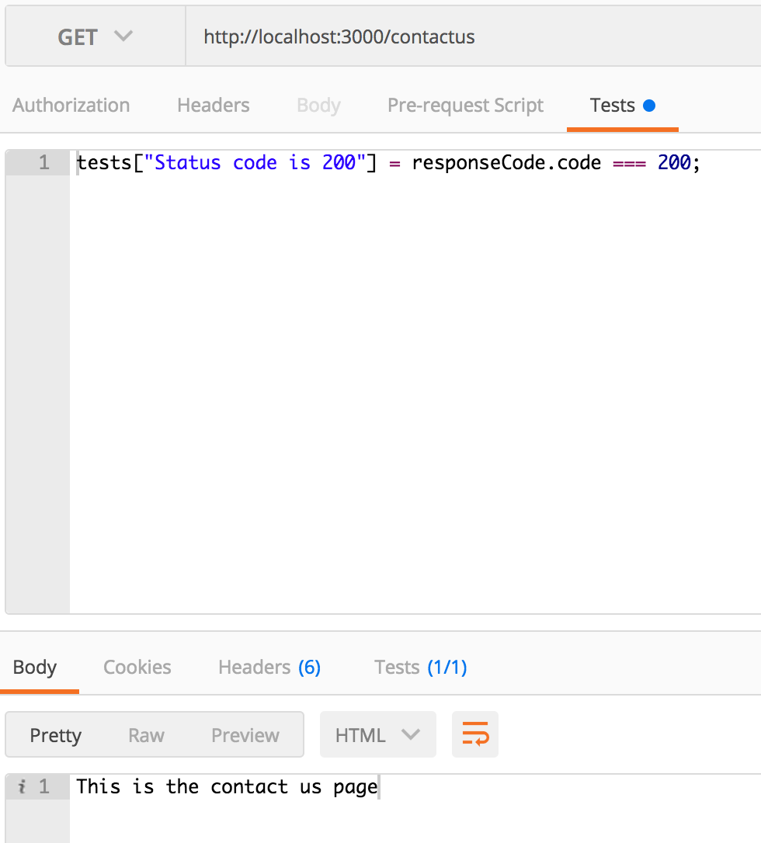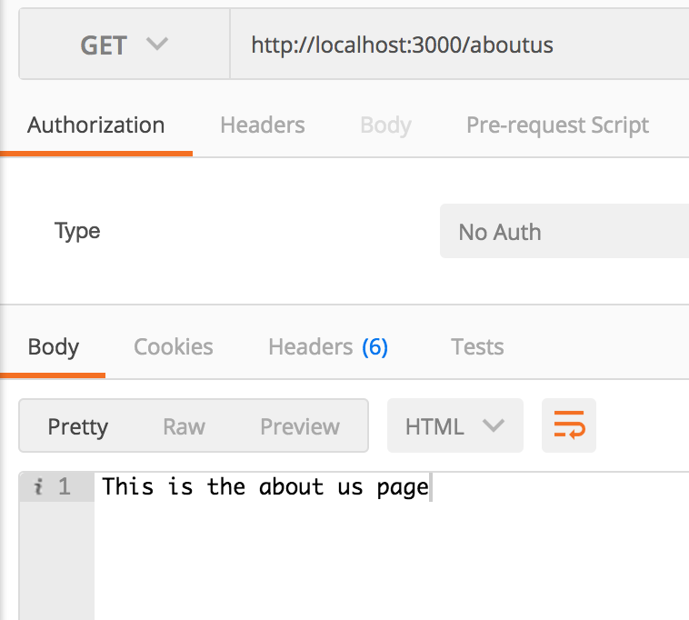

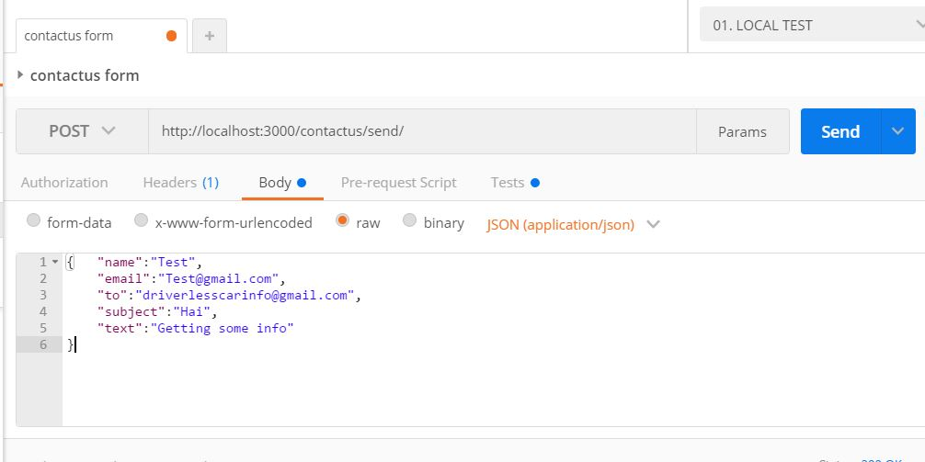

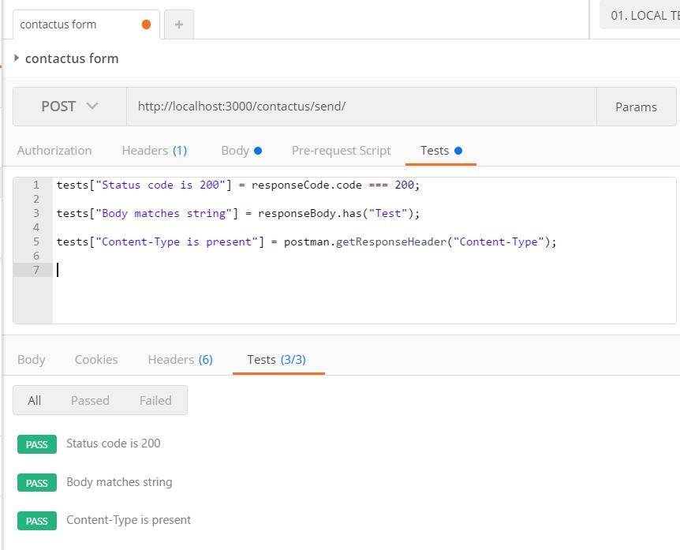

**Visual User Guide**

**Step1:** Developer starts server on localhost:3000

**Step1:** Developer browses and gets response back:

* [http://localhost:3000](http://localhost:3000/)/contactus
* [http://localhost:3000](http://localhost:3000/)/aboutus
* [http://localhost:3000](http://localhost:3000/)/mission
* [http://localhost:3000](http://localhost:3000/)/technology
* [http://localhost:3000](http://localhost:3000/)/team
* [http://localhost:3000](http://localhost:3000/)/product

